**Ideation Phase**

**Define the Problem Statements**

|  |  |
| --- | --- |
| Date | 20 June 2025 |
| Team ID | LTVIP2025TMID46195 |
| Project Name | BookNest |
| Maximum Marks | 2 Marks |

**Customer Problem Statement Template:**

Create a problem statement to understand your customer's point of view. The Customer Problem Statement template helps you focus on what matters to create experiences people will love.

A well-articulated customer problem statement allows you and your team to find the ideal solution for the challenges your customers face. Throughout the process, you’ll also be able to empathize with your customers, which helps you better understand how they perceive your product or service.

Reference: <https://miro.com/templates/customer-problem-statement/>

**Example:**

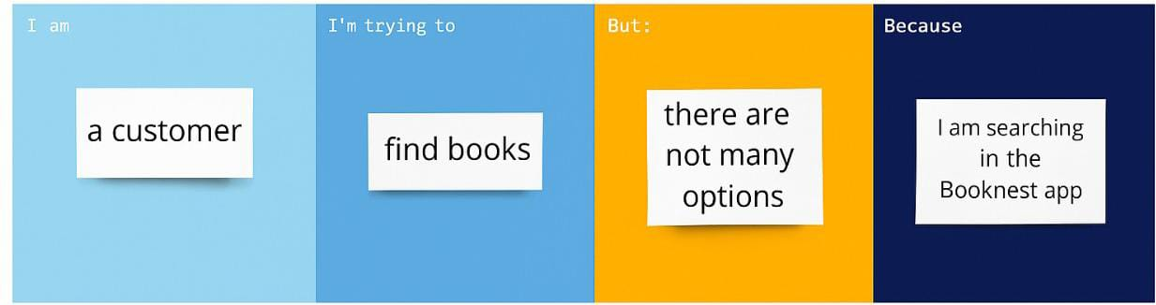

|  |  |  |  |  |  |
| --- | --- | --- | --- | --- | --- |
| **Problem Statement (PS)** | **I am (Customer)** | **I’m trying to** | **But** | **Because** | **Which makes me feel** |
| PS-1 | A frequent reader | Find new book recommendations based on my interests | I Keep seeing the same suggestions | The recommendation system isn’t personalized | Bored and unengaged |
| PS-2 | A student looking for academic books | Search and filter books by subject and author | The filters don’t work well on mobile | The interface is not optimized for small screens | Frustrated and discouraged |